Project Design Phase-II

Data Flow Diagram & User Stories

|  |  |
| --- | --- |
| Date | 15 October 2022 |
| Team ID | PNT2022TMID51330 |
| Project Name | Digital Naturalist - AI Enabled tool for  Biodiversity Researchers |
| Maximum Marks | 4 Marks |

**DATA FLOW DIAGRAM :**

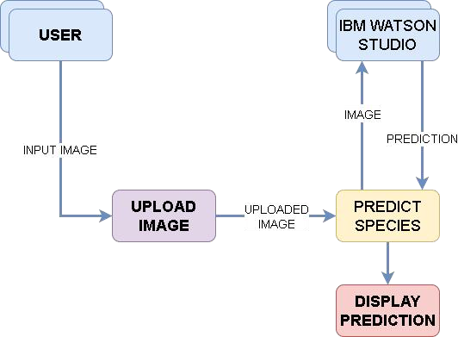

**User Stories :**

|  |  |  |  |  |  |  |
| --- | --- | --- | --- | --- | --- | --- |
| **User Type** | **Functional Requirement (Epic)** | **User Story Number** | **User Story / Task** | **Acceptance criteria** | **Priority** | **Release** |
| Customer (Web user) | Dashboard |  | As a user I can access the website to use this feature. | Displaying the dashboard | High | Sprint-3 |
| Customer (Web user) | Upload Image |  | As a user, I can upload image of an plant or animal species to identify it. | A dialog box stating a successful upload. | High | Sprint-1 |
| Customer (Web user) | Predict Image |  | As a user I can use this feature to predict a species. | The name of the species is displayed | High | Sprint-2 |